How to visualize your LinkedIn data using Claude 3.7 Sonnet
Included is a prompt you can adapt for your own projects.
Alex McFarland
Feb 26, 2025
∙ Paid

Transcript
LinkedIn contains a lot of your professional history, connections, and engagement patterns, but most of this valuable data just sits there unused.
With Claude 3.7's new capabilities, particularly the extended thinking mode, you can transform this raw information into interactive dashboards and visualizations that actually tell you something useful.
Like this:

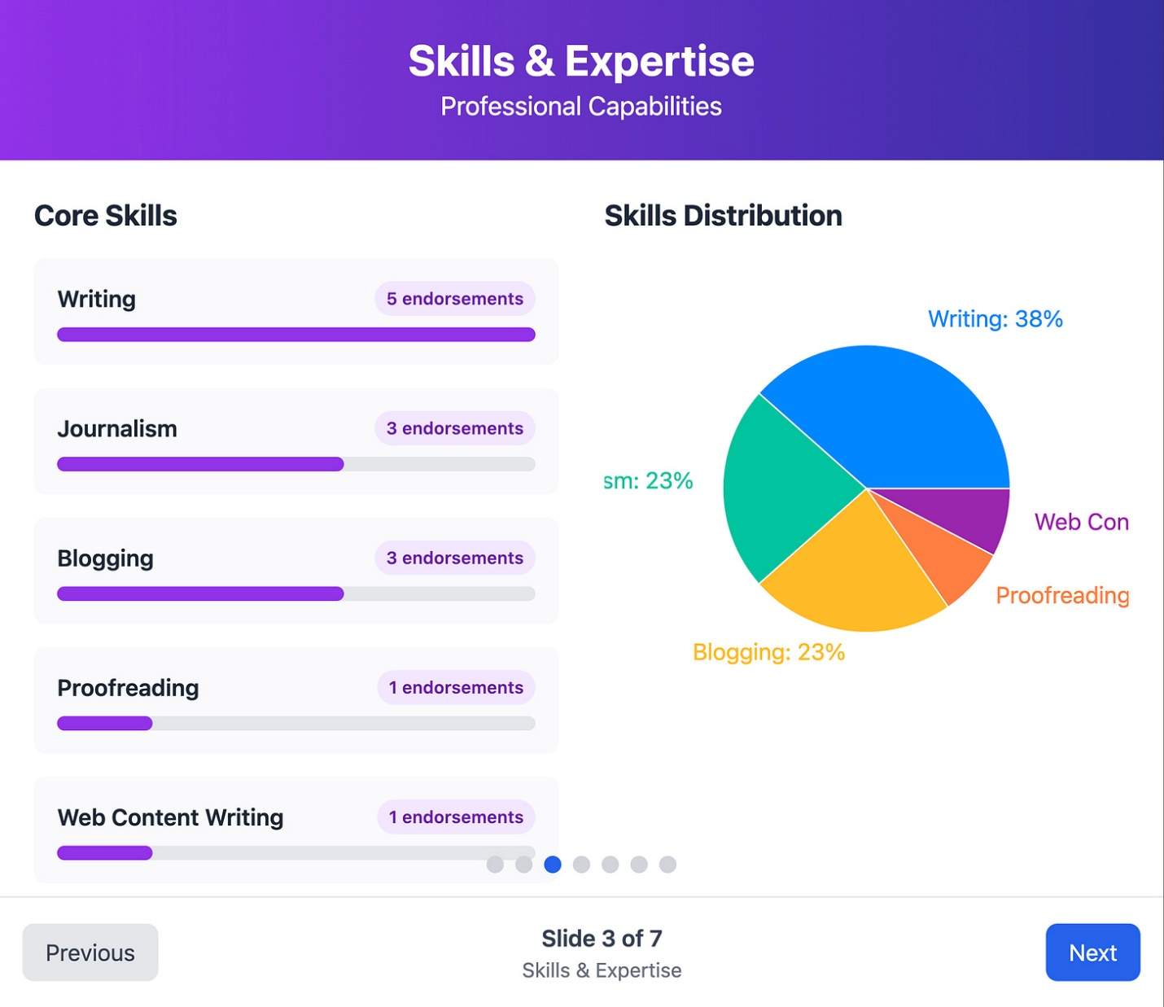

Or this:

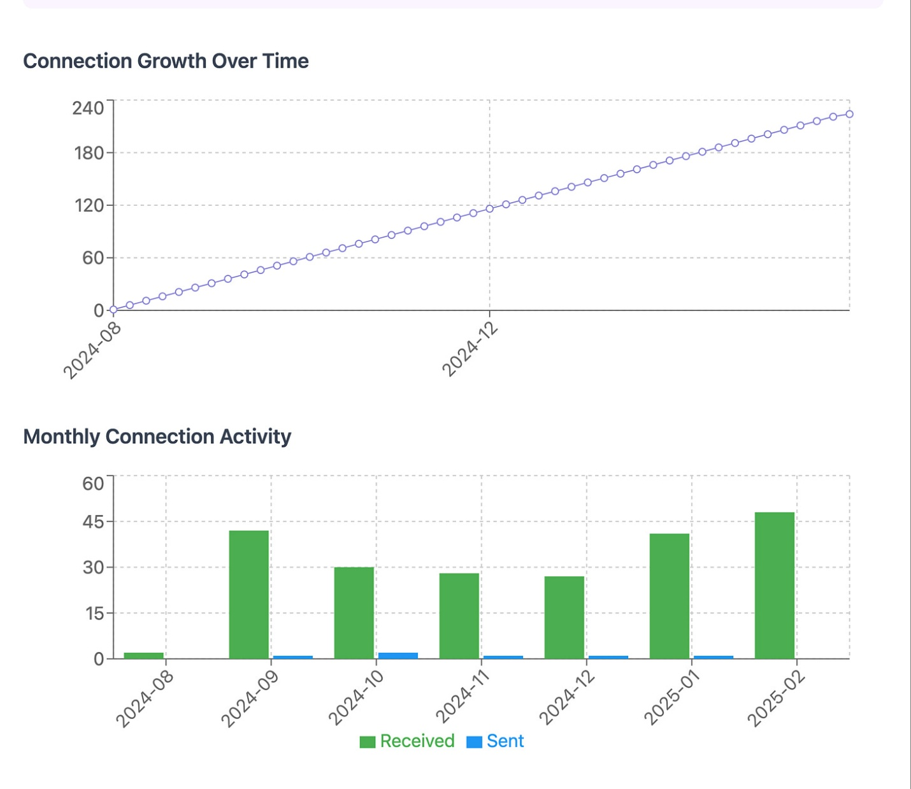

What's nice about this approach is that it requires zero coding knowledge, works with the free version of LinkedIn, and creates shareable visualizations you can use in presentations or reports.
I've been experimenting with this technique, and the results have been really insightful.

Exporting your LinkedIn data
The first step is getting your data out of LinkedIn. Here's how:
- Log into your LinkedIn account
- Click on your profile picture and select "Settings & Privacy"
- Navigate to "Data Privacy" on the left side
- Look for "Get a copy of your data" and click on it
- You have two options: download everything, or select specific data

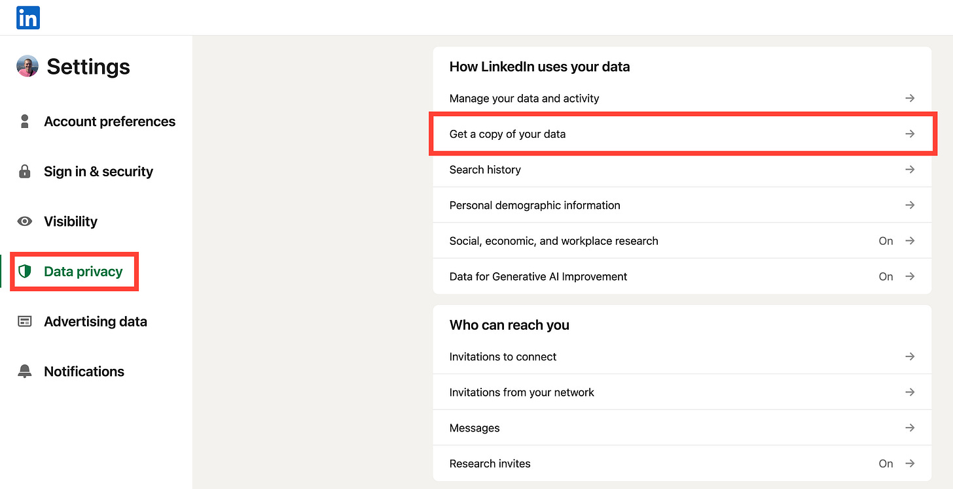

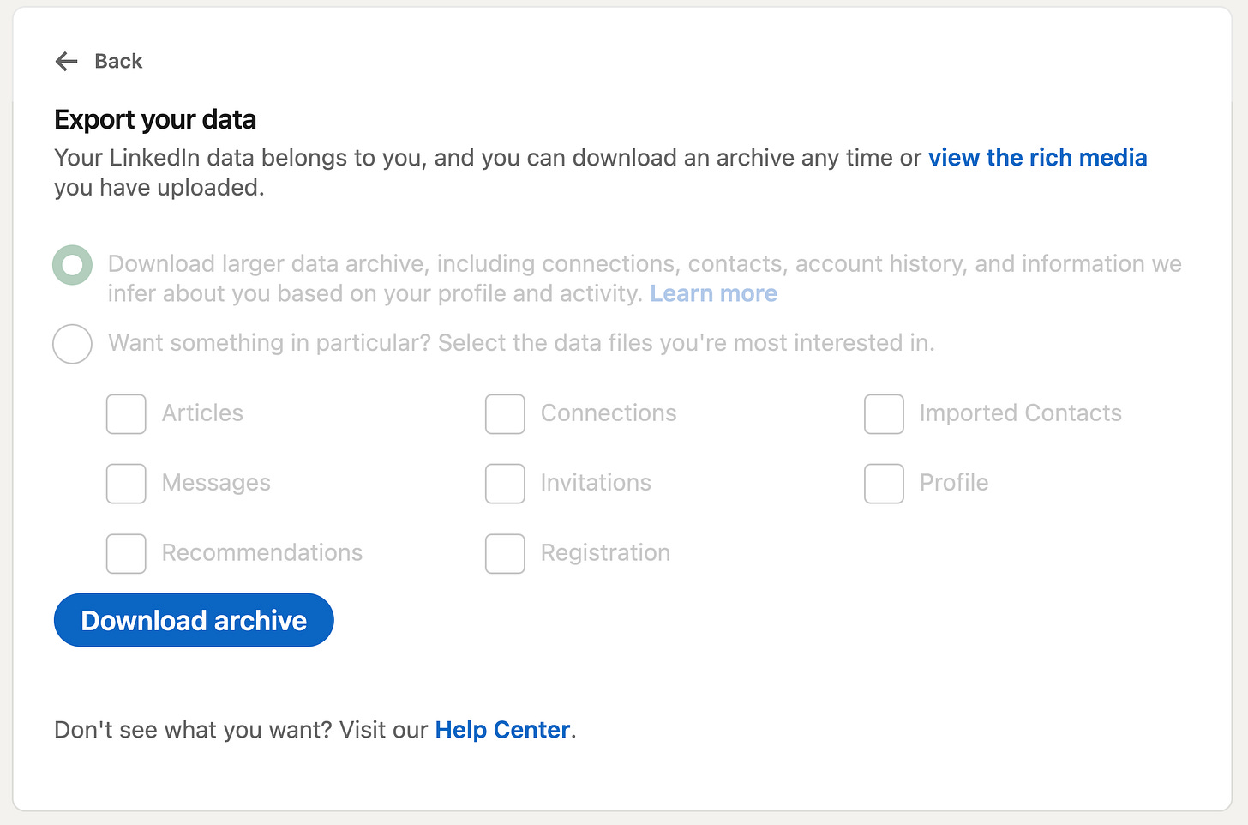

For this visualization project, I recommend focusing on these key files:
- Connections
- Messages
- Profile
- Skills
- Endorsements
- Education
- Positions
- Invitations
LinkedIn usually takes up to 24 hours to prepare your data for download. You'll receive an email notification when it's ready. Once downloaded, you'll get a zip file containing various CSV files with your data.
Important preparation step: Claude can only work with up to 20 files at once through the web interface. If you downloaded the complete archive, you'll need to clean it up first. Keep only the most relevant files listed above. (Or adjust based on your specific needs.)

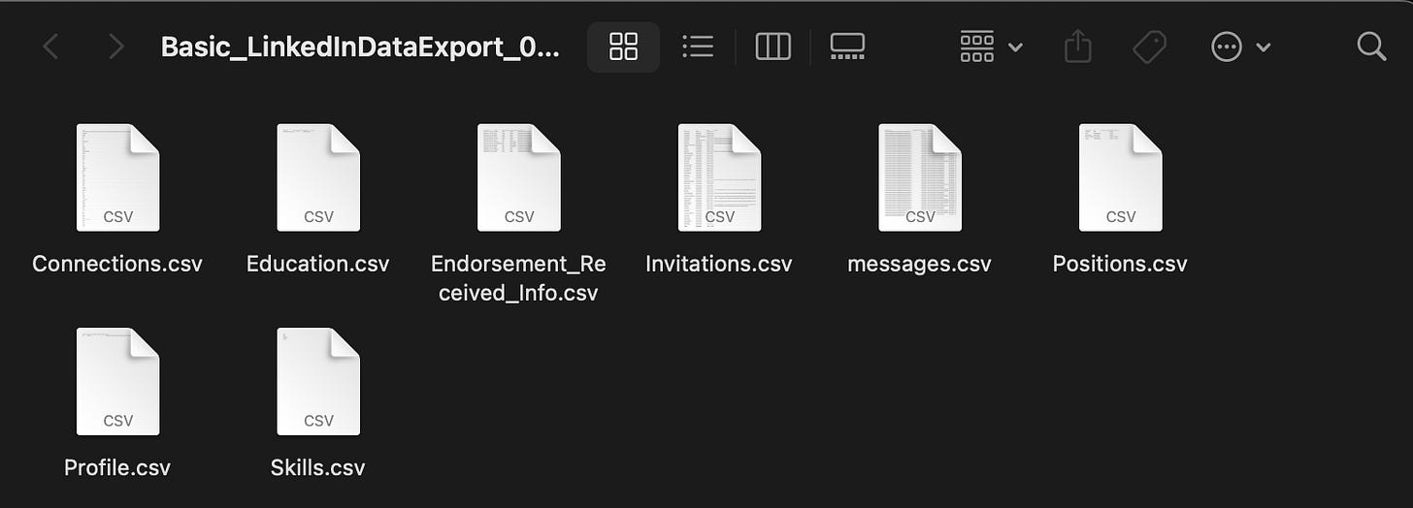

Setting up Claude 3.7 for visualization
With your data ready, it's time to create your visualizations:
- Start a new chat in Claude
- Select "Claude 3.7 Sonnet" as your model
- Enable "Extended thinking" mode (this makes a significant difference in the quality of visualizations)
- Upload your LinkedIn data files (up to 20)
- Use the prompt template I've provided below
The extended thinking mode is crucial here. It gives Claude time to properly analyze your data and create meaningful visualizations rather than rushing through the process.

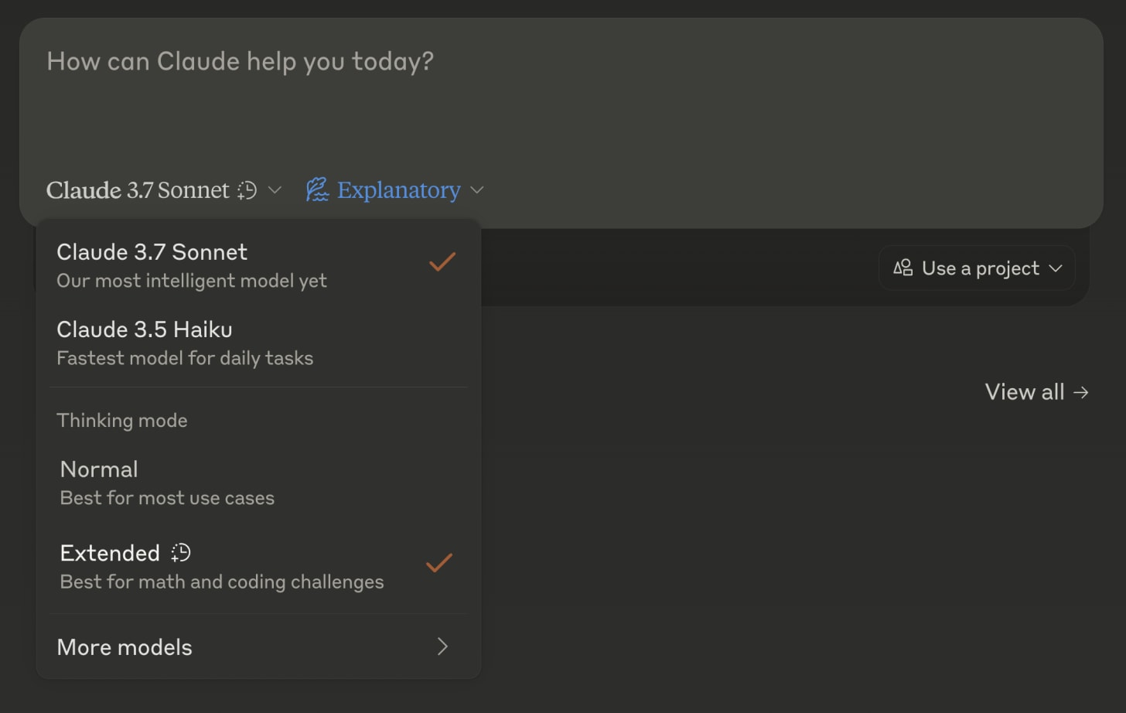

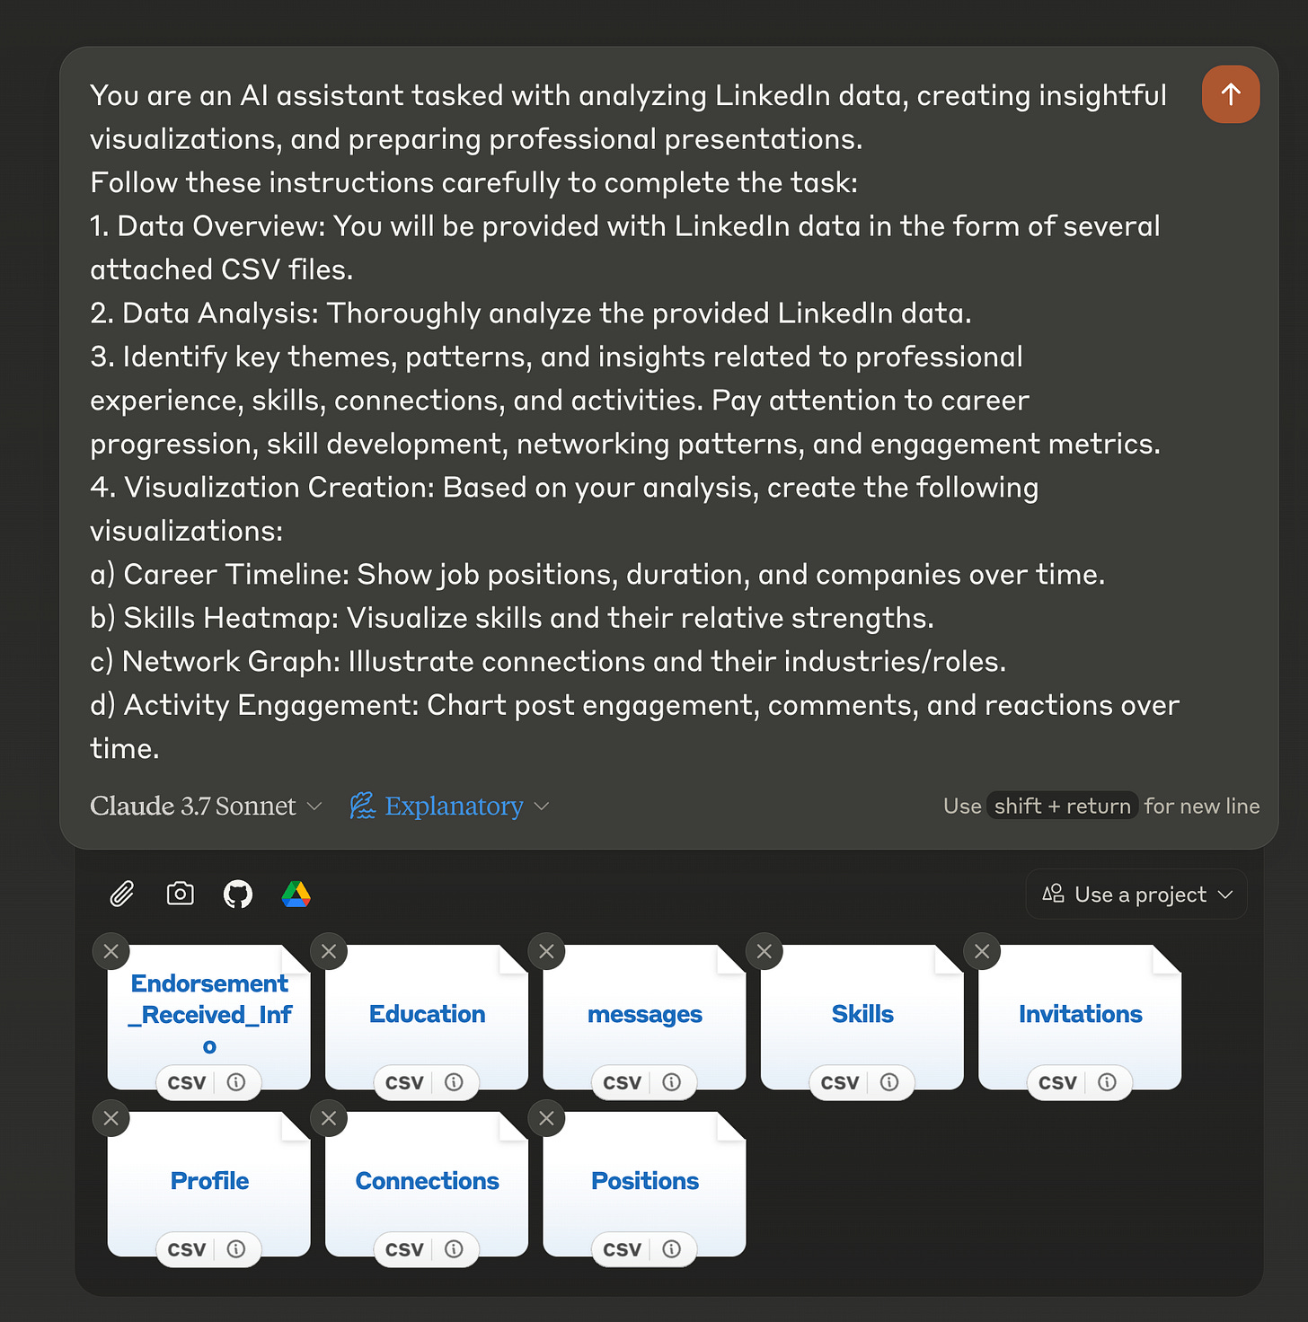

Prompt template for LinkedIn data visualization (Claude 3.7 Sonnet)

You are an AI assistant tasked with analyzing LinkedIn data, creating insightful visualizations, and preparing professional presentations.

Follow these instructions carefully to complete the task:

1. Data Overview: You will be provided with LinkedIn data in the form of several attached CSV files.

2. Data Analysis: Thoroughly analyze the provided LinkedIn data.

3. Identify key themes, patterns, and insights related to professional experience, skills, connections, and activities. Pay attention to career progression, skill development, networking patterns, and engagement metrics.

4. Visualization Creation: Based on your analysis, create the following visualizations:

a) Career Timeline: Show job positions, duration, and companies over time.
b) Skills Heatmap: Visualize skills and their relative strengths.
c) Network Graph: Illustrate connections and their industries/roles.
d) Activity Engagement: Chart post engagement, comments, and reactions over time.
e) Education Background: Display educational qualifications and institutions. f) Endorsements and Recommendations: Visualize the distribution of endorsements and key recommendations.

Ensure all visualizations are clear, informative, and visually appealing.

5. Slideshow Presentation: Create an interactive slideshow presentation (7 slides) that provides an overview of the individual and their professional network.

6. Client/Employer Brief: Develop a concise, one-page brief suitable for potential clients or employers. This should include: Professional headline, Summary of expertise, Key achievements, Core skills, Career progression, Notable projects or contributions, Contact information.

Make sure each of these 6 points is its own visualization/artifact.
Feel free to customize this template based on what aspects of your LinkedIn data you're most interested in exploring.

Understanding the visualizations
Once you run this prompt, Claude will spend several minutes analyzing your data (usually under 10 minutes with extended thinking mode). You'll see it work through each file systematically before creating the visualizations one by one.
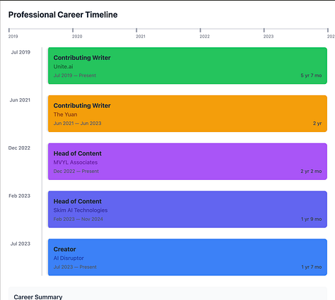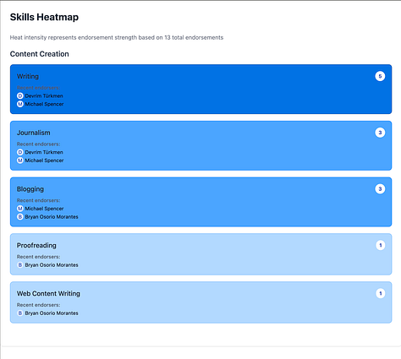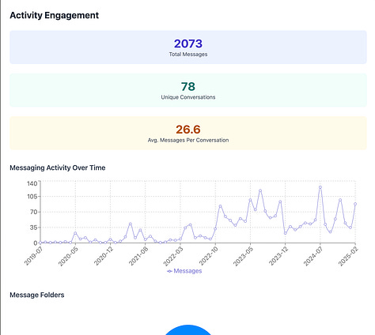
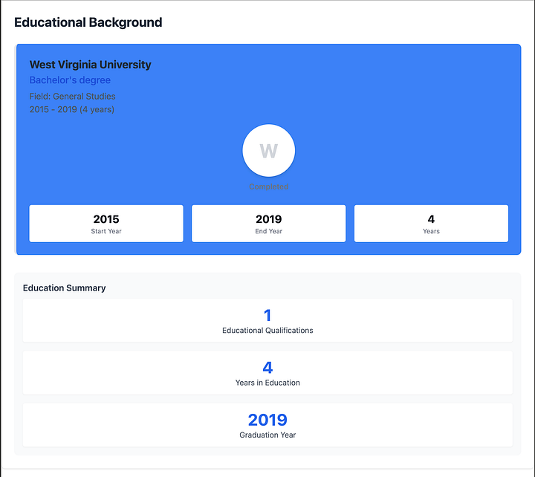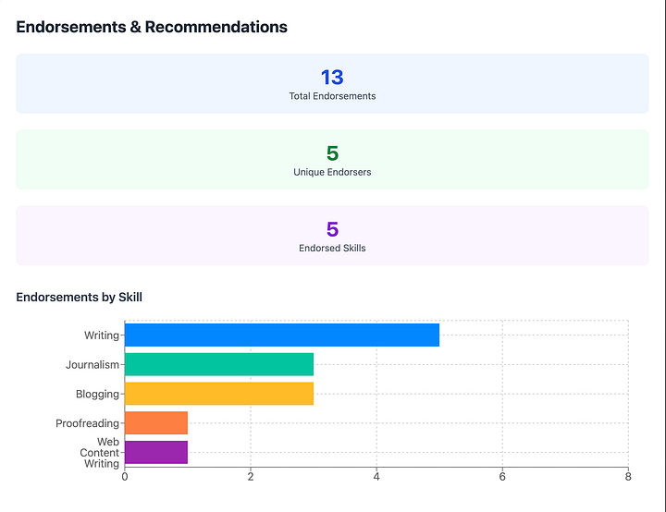
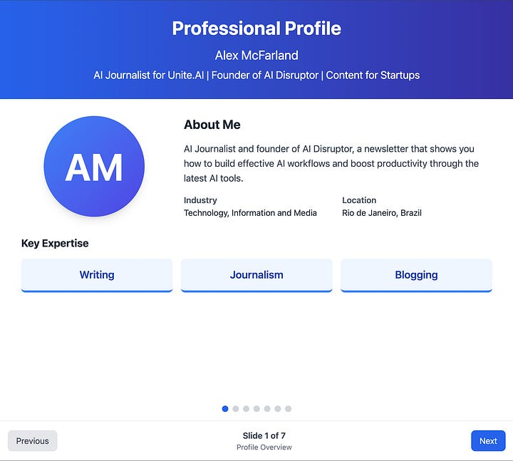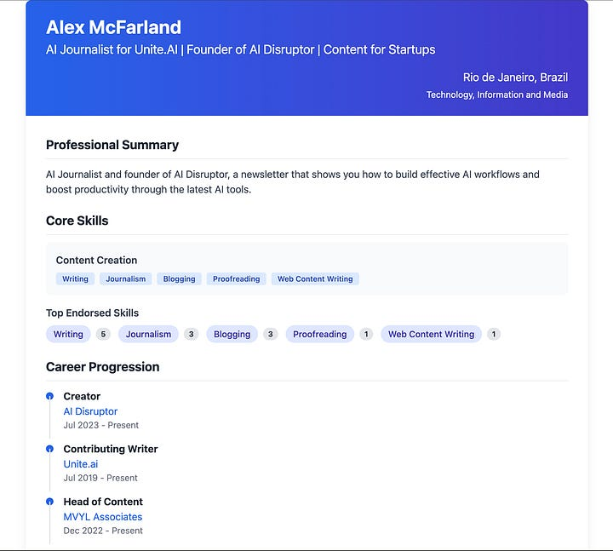
Here's what each visualization typically shows:
Career Timeline
This visualization maps your professional journey chronologically. It should show your various positions, duration at each role, and career progression. If this visualization isn't clear enough on the first try (mine wasn't), you can ask Claude to recreate it with more specific instructions.
Skills Heat Map
This shows your endorsed skills with a color gradient indicating endorsement strength. It's a quick way to see how others perceive your professional strengths. The darker colors typically represent areas where you've received more endorsements.
Network Connections
This visualization analyzes your connection growth over time, showing patterns in how your network has expanded. It typically includes metrics like:
- Total connections
- Connection growth rate
- Monthly connection activity
- Patterns in sent vs. received invitations
Activity Engagement
This dashboard visualizes your messaging and engagement patterns. It can include:
- Total messages sent/received
- Number of unique conversations
- Average messages per conversation
- Messaging trends over time
- Common conversation topics or themes
Education Background
A simple but effective visualization of your educational history, including institutions, degrees, and timelines. This is particularly useful if you have multiple degrees or certifications.
Endorsements & Recommendations
This visualization breaks down who has endorsed you, for what skills, and how these endorsements have accumulated over time. It can help identify your strongest professional advocates.

Improving your visualizations
Here's something important: you won't always get perfect visualizations on the first try. If you're not satisfied with a particular visualization, simply tell Claude what you don't like about it and ask for a revision.
For example, when I first generated my career timeline, it was confusing and cluttered. I simply told Claude: "I don't like the career timeline visualization. It's confusing. Can you clean it up?" and it created a much clearer version on the second try.
For visualizations you want to keep, I recommend using the "Publish" option that appears below each artifact. This creates a standalone link to the interactive visualization that you can share or embed elsewhere.

Additional applications
While this guide focuses on LinkedIn data, the same approach works for virtually any structured data you can export:
- Twitter/X analytics exports
- Google Analytics data
- Email engagement metrics
- CRM exports
- Sales or marketing performance data
The key is having structured data (ideally CSV files) and a clear idea of what insights you're looking for.
One thing I've learned through experimentation: don't feel obligated to use my exact prompt. The real power comes when you adapt it to your specific needs. Maybe you don't care about education history but want deeper analysis of your connection patterns. Customize accordingly.

If you've made it this far, here's what I recommend doing:
- Export your LinkedIn data today (since it takes time to process)
- While waiting, think about what specific insights would be most valuable to you
- When your data is ready, run the prompt with Claude 3.7
- Share your most interesting visualization by publishing the artifact and posting the link in the comments
I'm genuinely curious to see what insights you discover about your professional history and connections. And don't stop at LinkedIn—think about what other data sources in your professional life might benefit from this kind of visualization.

